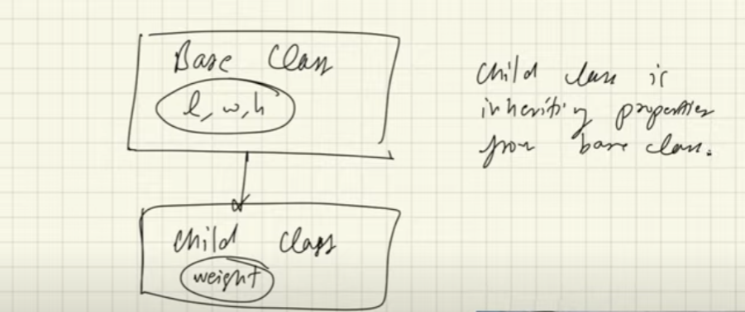

child class is inheriting the properties from the base class or the parent class

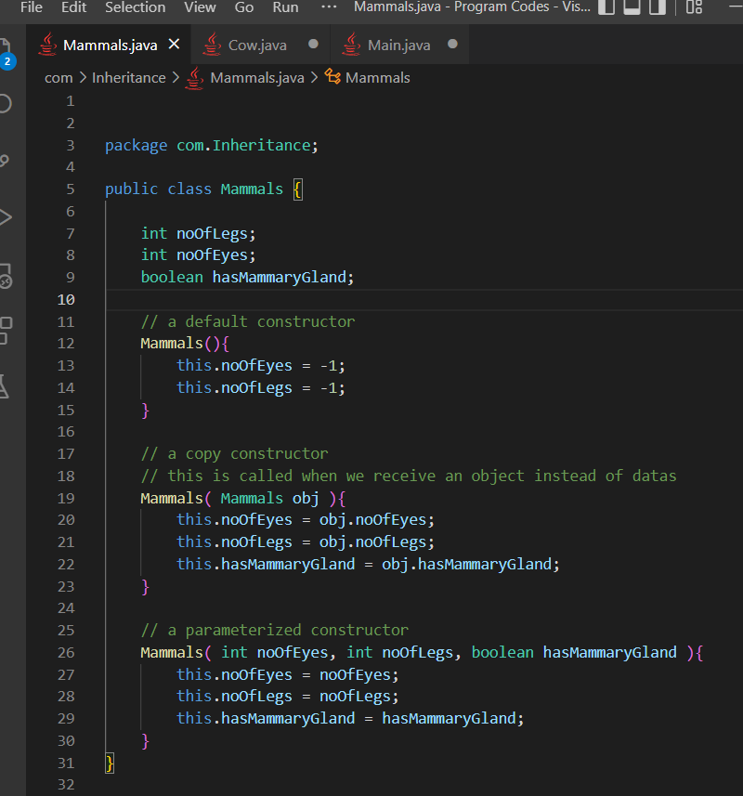

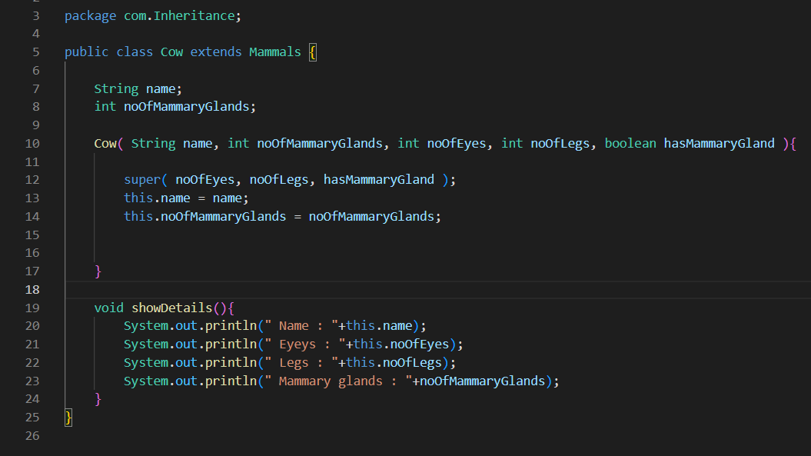

1. We use the extends keyword while creating the class to do inheritance
2. We use super ( ) method to access the constructor of the parent class from the child class
3. Child ko constructor bhitra surumaa super () lai call garnae and only assign the values to the variables of the child class, but the first line inside the child constructor is to call super( )

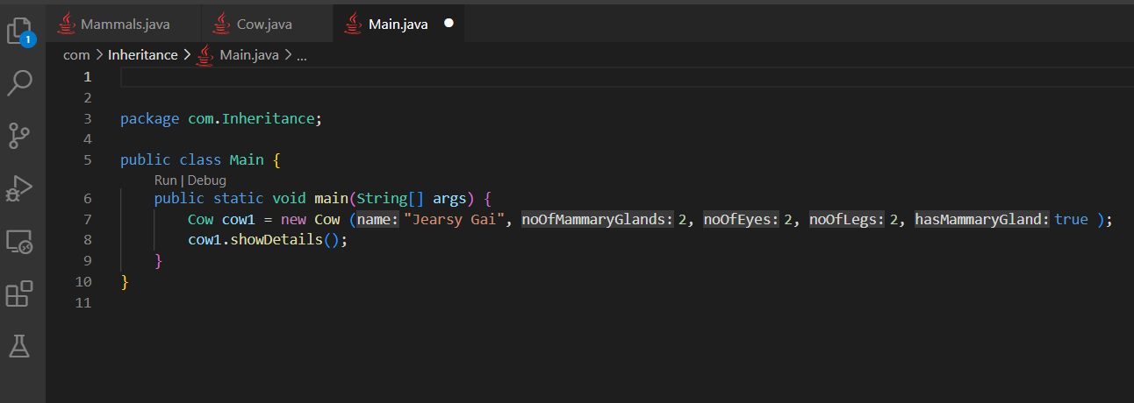

Also the inheritance in java script is also same as here in Java

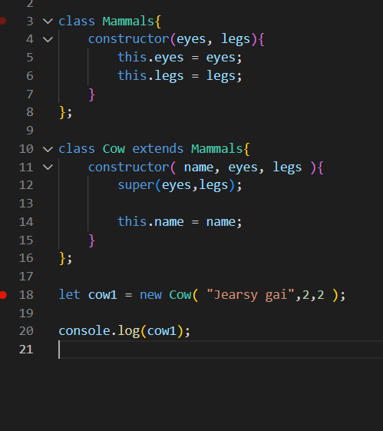

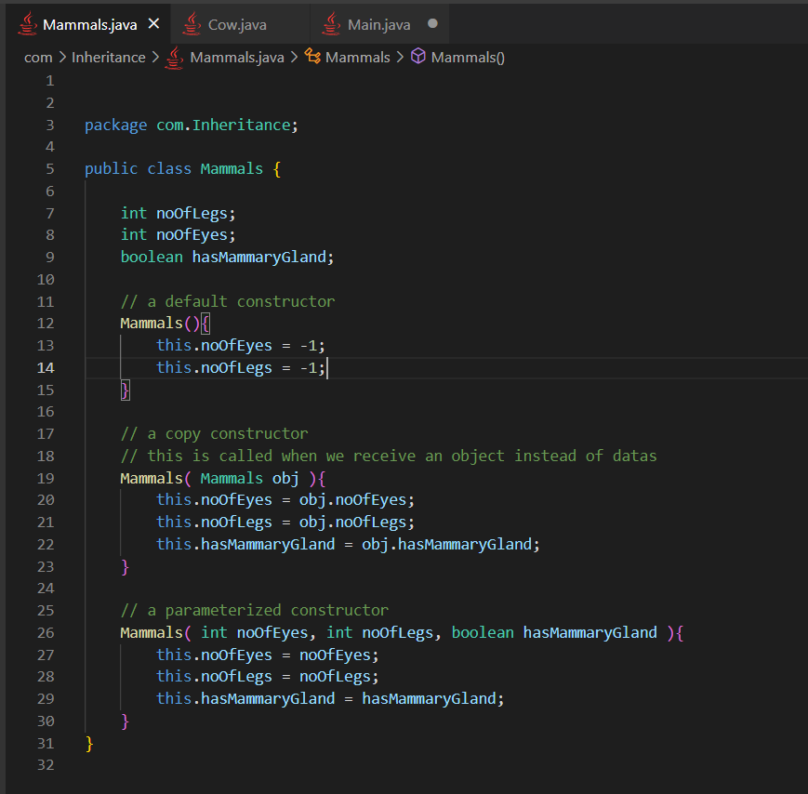

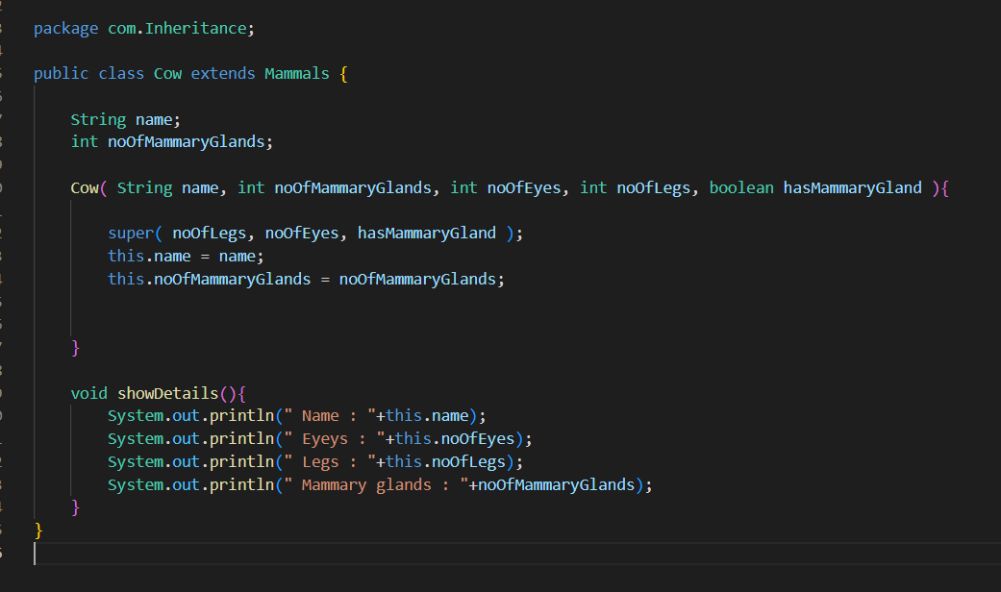

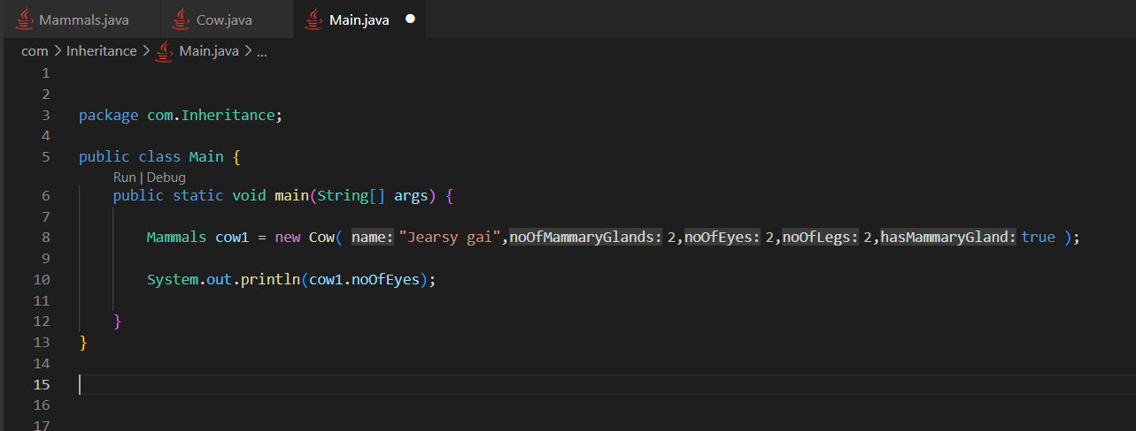

**Rule says that**

**Only the properties of the data type of the reference variable will be accessed by the reference variable through dot operator AND NOT OTHERS, for example if the reference variable is of parent class type it will only access the properties of the parent class not the child class. In above reference variable cow1, which is of type parent class can not access the properties defined in the Cow class which is the child class**

**Here the reference variable is of type Mammals, so only the properties of the mammals class will be accessed by the reference variable through . operator**

**Here**

**The reference variable is of Mammals type**

**The object pointed by the reference variable is of type Cow**

**We can have reference variable of parent class pointing to the object of the child class**

**Here is the reason**

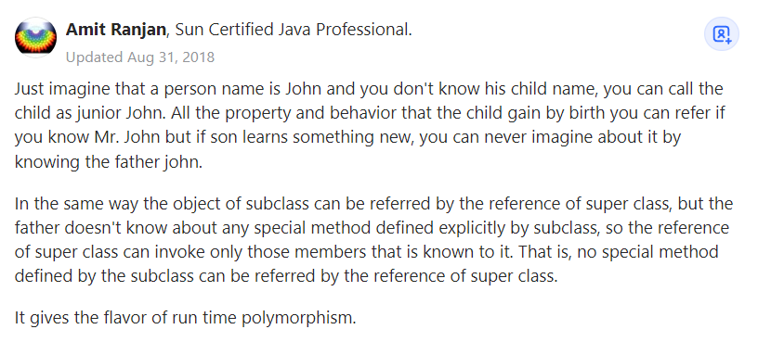

**Object class in Java**

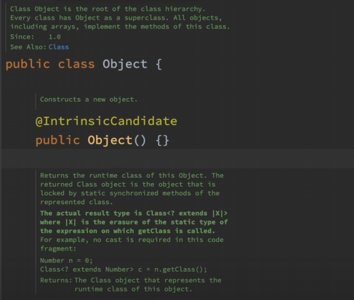

The internal implementation of java says

Object class is the super class of every single class created in the java program including classes like Array

So every single class can access the properties of the Object class

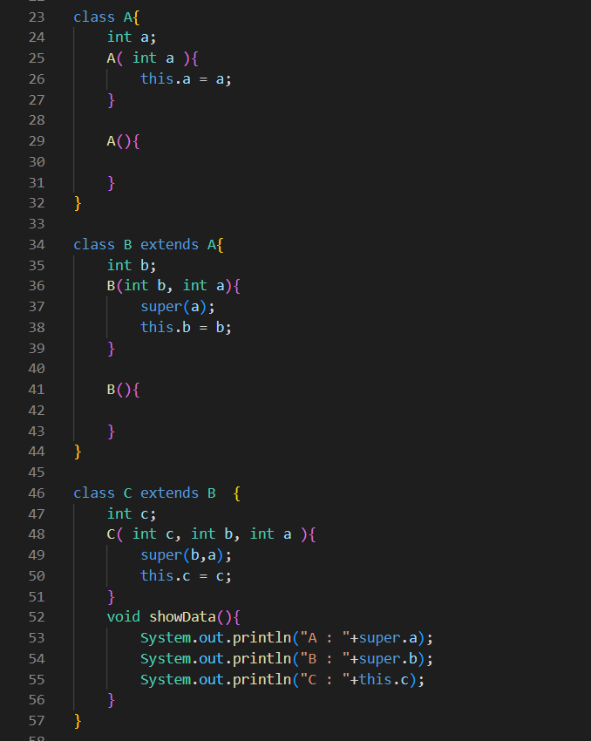



We made use of super. Instead of this. Which is much more easier to understand

Also **super.a** actually worked when class A is actually two step above of class C

So at first I thought something of **super.super.a**

**Single Inheritance**

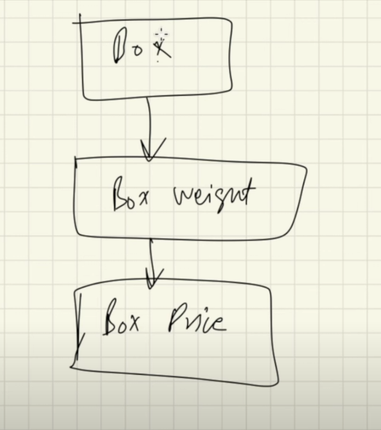

Box is the parent class of BoxWeight class and BoxWeight class is the parent class of the child class BoxPrice

Here the constructor of child class is called while making object, which will call the constructor of it’s super class via super( ) method, which is again call constructor of it’s super class via super( ) method

The super( ) method is the very first line of any constructor in inheritance, then only we can do other stuffs in inheritance

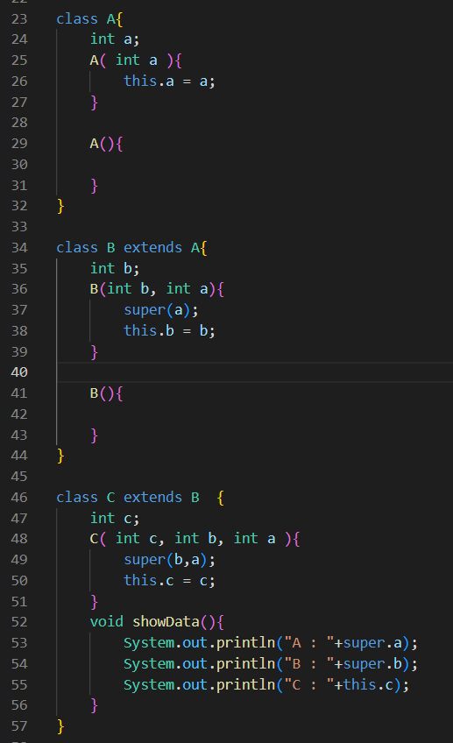

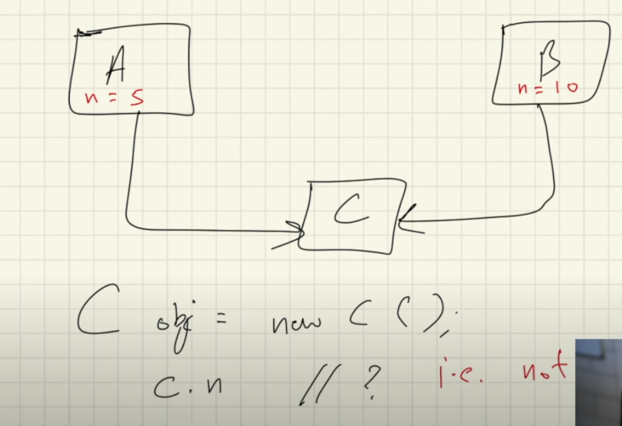

Inheritance like this, multiple inheritance where the child class is inheriting from the multiple parent class is not supported in java. For example in above, on doing c.n java won’t know which n to pick

For this java has something called abstract classes and interfaces

**Hierarchial inheritance**

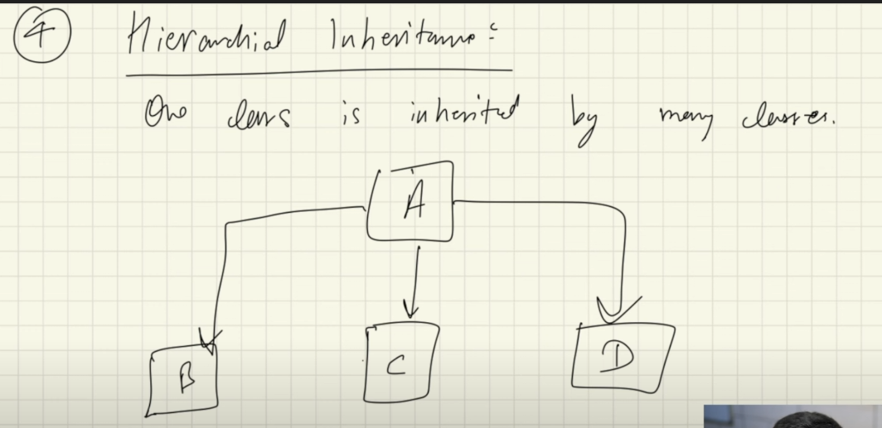

Here one parent class is inherited by the many child classes